**Prayer of Pope Francis for an end to the Coronavirus Pandemic   
Letter to the Faithful 25th of April 2020**

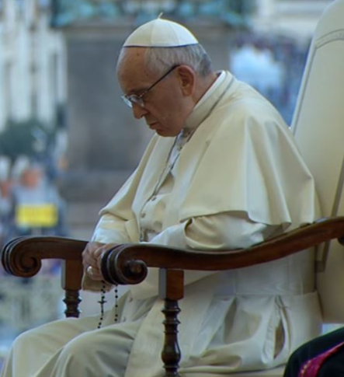 **“We fly to your protection, O Holy Mother of God”.** Taken from the *memore* of St. Bernard.

In the present tragic situation, when the whole world is prey to suffering and anxiety, we fly to you, Mother of God and our Mother, and seek refuge under your protection.

**Virgin Mary**, turn your merciful eyes towards us amid this coronavirus pandemic. Comfort those who are distraught and mourn their loved ones who have died, and at times are buried in a way that grieves them deeply. Be close to those who are concerned for their loved ones who are sick and who, in order to prevent the spread of the disease, cannot be close to them. Fill with hope those who are troubled by the uncertainty of the future and the consequences for the economy and employment.

**Mother of God and our Mother**, pray for us to God, the Father of mercies, that this great suffering may end and that hope and peace may dawn anew. Plead with your divine Son, as you did at Cana, so that the families of the sick and the victims be comforted, and their hearts be opened to confidence and trust.

Protect those doctors, nurses, health workers and volunteers who are on the frontline of this emergency, and are risking their lives to save others. Support their heroic effort and grant them strength, generosity and continued health. Be close to those who assist the sick night and day, and to priests who, in their pastoral concern and fidelity to the Gospel, are trying to help and support everyone.

**Blessed Virgin**, illumine the minds of men and women engaged in scientific research, that they may find effective solutions to overcome this virus. Support national leaders, that with wisdom, solicitude and generosity they may come to the aid of those lacking the basic necessities of life and may devise social and economic solutions inspired by farsightedness and solidarity.

**Mary Most Holy**, stir our consciences, so that the enormous funds invested in developing and stockpiling arms will instead be spent on promoting effective research on how to prevent similar tragedies from occurring in the future. Beloved Mother, help us realise that we are all members of one great family and to recognise the bond that unites us, so that, in a spirit of fraternity and solidarity, we can help to alleviate countless situations of poverty and need. Make us strong in faith, persevering in service, constant in prayer. Mary, Consolation of the afflicted, embrace all your children in distress and pray that God will stretch out his all-powerful hand and free us from this terrible pandemic, so that life can serenely resume its normal course.

To you, who shine on our journey as a sign of salvation and hope, do we entrust ourselves, O Clement, O Loving, O Sweet Virgin Mary. Amen.

Rome, Saint John Lateran, 25 April 2020, FRANCIS.